HOOKE’S LAW EXPERIMENT

Student’s Name:

Date of submission:

Institution Affiliation:

ABSTRACT
Robert Hook discovered a law which states that when a stretching spring is loaded, force applied is directly proportional to extension produced in it. In this evaluation, we plan to contemplate the flexible characteristics of the spring and the force consistent of the spring. We plan to reflect on consideration on the relationship among the twisting strength and sum the spring extends.

INTRODUCTION

Elasticity is the property of a piece of fabric which makes it regain to its particular shape after mutilation. An elastic band can be stretched and snaps again to close to its unique period while discharged, yet it isn't always as flexible as a piece of piano twine.

Hooke's law is a regulation of versatility determined by a scientist called Robert Hooke in mid-17th century, it states that, when a certain force is applied on the spring, there is an increase in length. When the force causing displacement is withdrawn, the spring regains its original length. He therefore concluded that force is directly proportional to increase or decrease in length.In his law load is directly proportional to extension as long as the elastic limit is not exceeded. When a graph of force against extension is drawn, a straight-line graph. But when a load exceeding the elastic limit is applied, the spring will behave uniquely. After the elastic limit, the graph will not be a straight line. He therefore introduced a factor called spring constant which helps us to determine the maximum load a spring can carry without undergoing permanent deformation.

In other words,the law is also expressed mathematically as; spring constant (k) is equal to thequotient of the applied force and extension (x). The SI unit for spring constant is N/m while that of extension is meters (m).

Hooke's law is can alsocalculated using stress and strain.

- MATERIALS AND METHODS

The materials required for this research are 1 set of Hooke's regulation apparatus, 2pieces0.15sN/m springs, 1-piece mass holder and 1 set of mass. Fig (1) demonstrates a photograph of the materials.
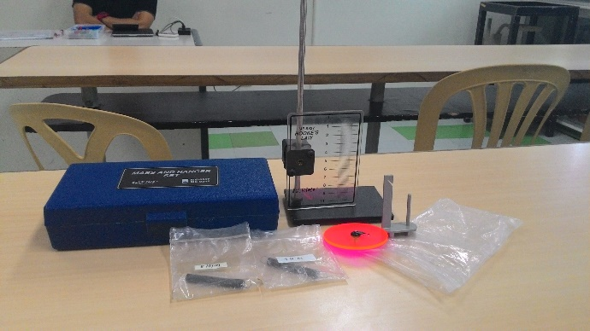
Fig 1 shows materials used in this experiment
Previous to continuing with the research, there are a few updates toward hardware care. By no means enlarge the spring extra than twice its resting duration, it may forever damage the spring.

Initial segment of the check is setting up the mechanical meeting. The spring was swung from the notch at the assist arm. The stretch marker was associated with the bottom of the spring. The clip at the assist bar turned into balanced till the pointer perusing is adjusted at precisely zero, at that point the mass holder become associated on the bottom of the stretch markerfigure (2) and (three) demonstrates the set-up of the mechanical meeting.
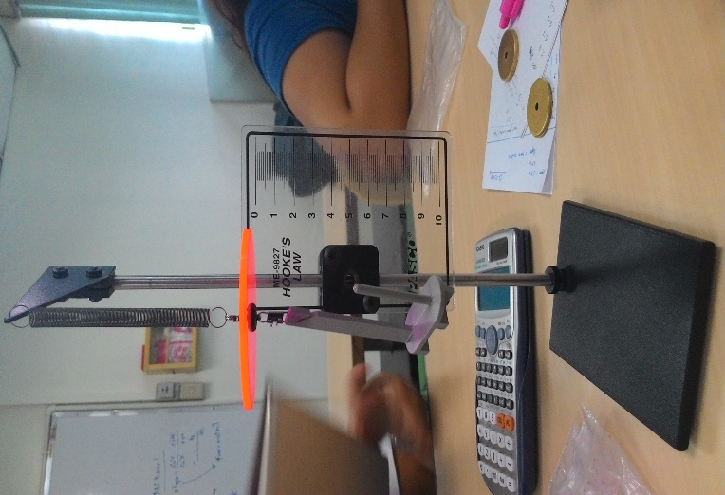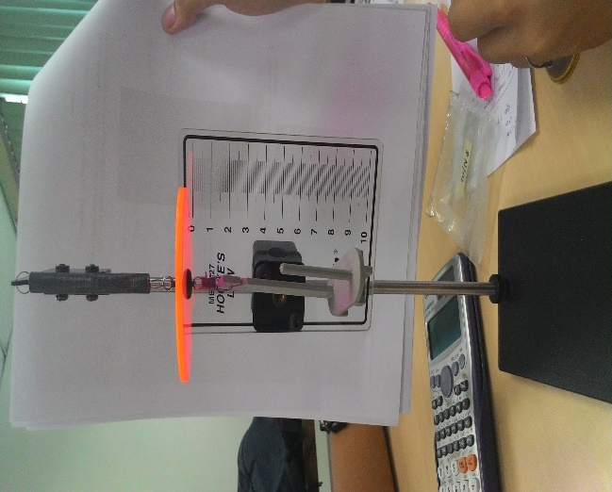
Fig2 shows a spring of 0.15N/cm
Fig 3 shows a spring of 0.15N/cm
Second part of the experiment is determining the force constant of the spring. To start, a mass of 50 grams was placed on the mass hanger as shown in Figure (4), then the change in displacement of the spring and the weight of the hanging mass was recorded. Spring was computed using the formula;
(1)
F = k*x
Where
F =force (N)
x = displacement (m; cm)
k = force constant (N/m; dynes/cm)

Equal strategies were made to the subsequent 3 preliminaries and in line with preliminary, a 50-gram mass being included. The normal estimation of the spring constant became resolved at that factor plot a power as opposed to dislodging chart. The strategies become rehashed, but this time some other spring become applied seemed in figure (5).
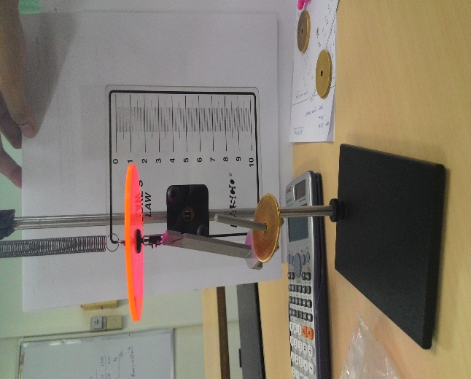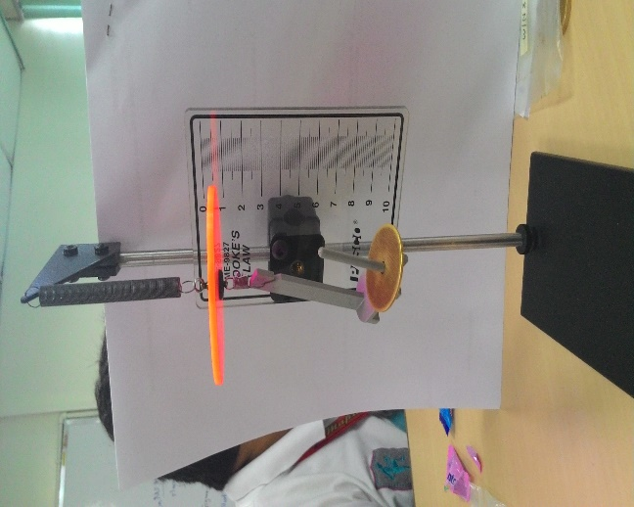
Figure 4: For trial 1, using a 0.15N/cm spring, a 50-gram mass was added to the mass hanger. The displacement of the spring is 3.3 cm
Figure 5: A0.15N/cm spring was used for the next trial. A 40-gram was placed on the mass hanger and its displacement is 26.2 cm
Third section is determining the work done when the spring is loaded. By interpratig the data gathered in the second part, the total work done in stretching the spring was computed using Equation (2).
(2)
$$W=\frac{1}{2}k(x_{f}^{2}-x_{0}^{2})$$

Where: x_{f} = displacement in fourth trial of section two of the experiment
x_{o}= 0

The area under the graph of force verses displacement was determined and compare the total work done and area under the graph of force vs. displacement.

- RESULTS AND DISCUSSION

In determining the force constant of the spring, data gathered are shown in Attempt 1,2&3 using a spring a spring of 0.5N/cm and the sample computations are presented below.

Attempt 1

Mass | Position (x) | Displacement (from origin) | Displacement (from previous position)
0g (origin) | 47.1cm (origin) | 0cm | 0cm
50g | 50.4cm | 3.3cm | 3.3cm
100g | 53.7cm | 6.6cm | 3.3cm
150g | 57cm | 9.9cm | 3.3cm
200g | 60.4cm | 13.3cm | 3.4cm
250g | 63.5cm | 16.4cm | 3.1cm
3009 | 66.6cm | 19.5cm | 3.1cm
350g | 70.1cm | 23cm | 3.5cm
400g | 73.4cm | 26.3cm | 3.3cm

Attempt 2
Mass | Position (x) | Displacement (from origin) | Displacement (from previous position)
0g (origin) | 47.1cm (origin) | 0cm | 0cm
50g | 50.5cm | 3.4cm | 3.4cm
100g | 53.7cm | 6.6cm | 3.2cm
150g | 57cm | 9.9cm | 3.3cm
200g | 60.4cm | 13.3cm | 3.4cm
250g | 63.5cm | 16.4cm | 3.1cm
300g | 66.8cm | 19.7cm | 3.3cm
350g | 70.1cm | 23cm | 3.3cm
400g | 73.3cm | 26.2cm | 3.2cm

Attempt 3
Mass | Position (x) | Displacement (from origin) | Displacement (from previous position)
0g (origin) | 47.1cm (origin) | 0cm | 0cm
50g | 50.4cm | 3.3cm | 3.3cm
100g | 53.7cm | 6.6cm | 3.3cm
150g | 57.1cm | 10cm | 3.4cm
200g | 60.4cm | 13.3cm | 3.3cm
250g | 63.6cm | 16.5cm | 3.2cm
300g | 66.8cm | 19.7cm | 3.2 cm
350g | 70.1cm | 23cm | 3.3cm
400g | 73.4cm | 26.3cm | 3.3cm

Average Extension

Mass | Extension  Trial 1 | Extension  Trial 2 | Extension  Trial 3 | Extension  Average(cm)
0g (origin) | 0cm | 0cm | 0cm | 0
50g | 3.3cm | 3.4cm | 3.3cm | 3.33
100g | 6.6cm | 6.6cm | 6.6cm | 6.60
150g | 9.9cm | 9.9cm | 10cm | 9.93
200g | 13.3cm | 13.3cm | 13.3cm | 13.30
250g | 16.4cm | 16.4cm | 16.5cm | 16.16
300g | 19.5cm | 19.7cm | 19.7cm | 19.16
350g | 23cm | 23cm | 23cm | 23.00
400g | 26.3cm | 26.2cm | 26.3cm | 26.26

Graph 1 (Drawn using data from attempt 1)
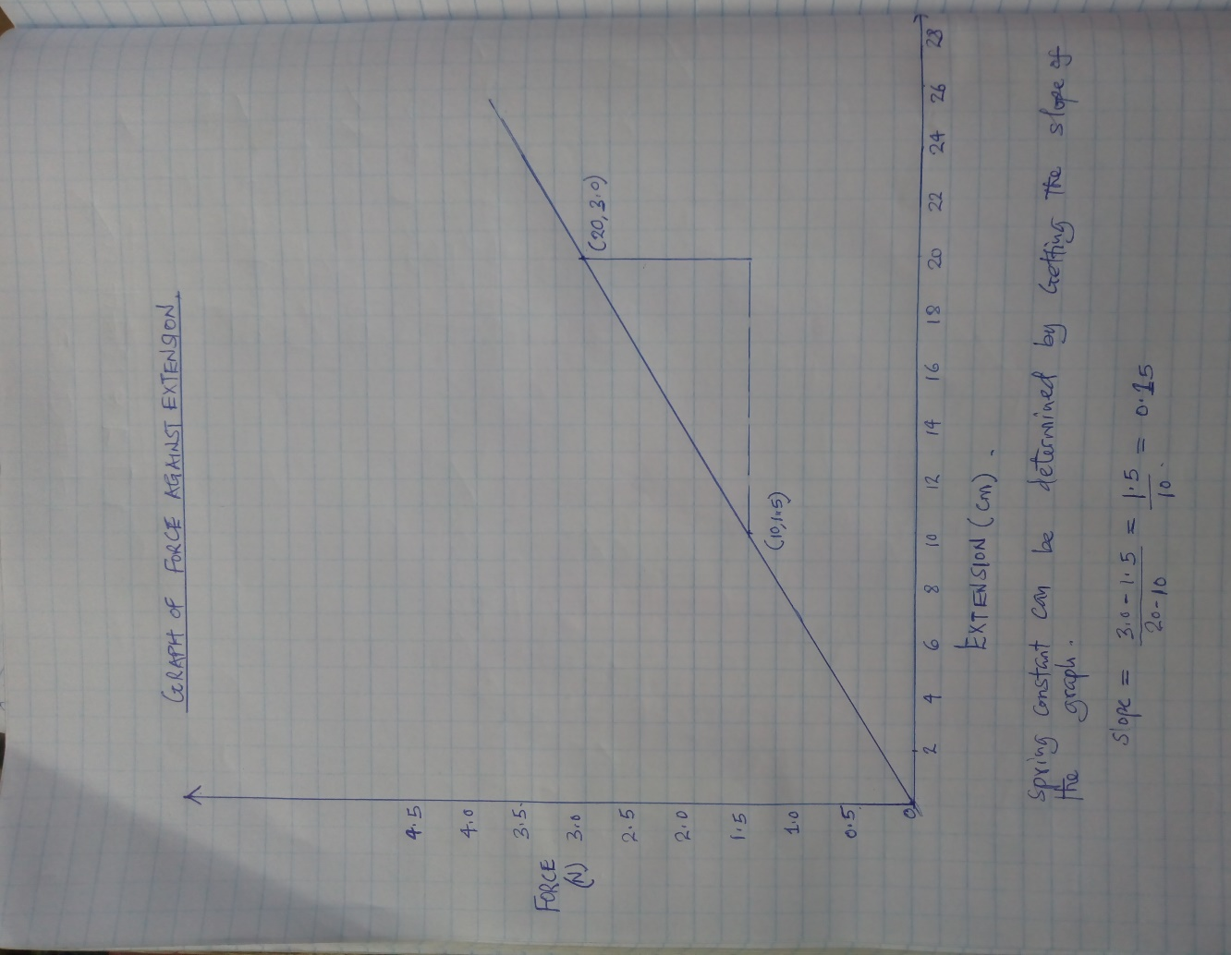

Graph 2 (Drawn using data from average table)
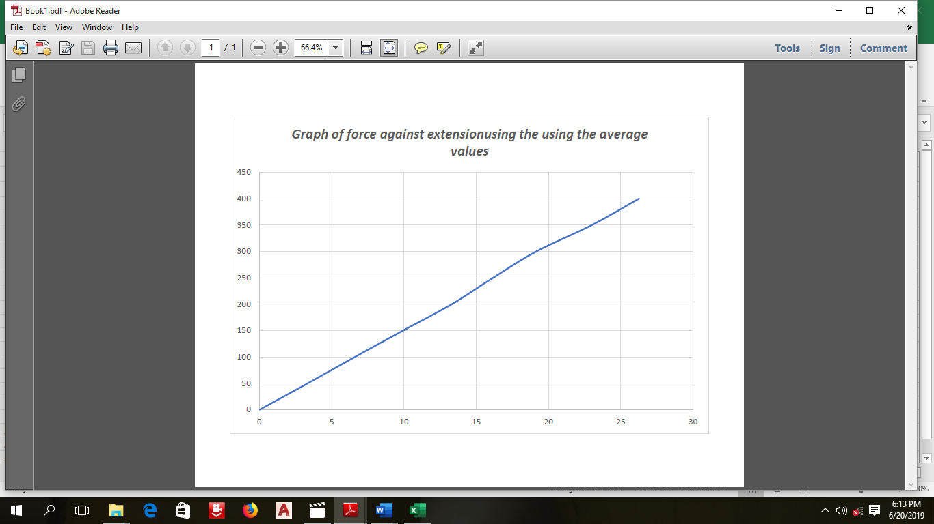
Calculations
The spring constant can also be determined the formula which was discussed ( F=ke ).
K=$\frac{F}{e}$
Using the values from the average table and picking any values corresponding to each other;
Force=1.5N
Extension= 9.93
K=$\frac{F}{e}$
K=$\frac{1.5}{9.93}$
=0.151
- DATA ANALYSIS
By analysing the above graph, it is observedthat as force enlarges, the length or displacement also enlarges. It implies that load is directly proportional to its displacement. Same with the results in the average table, the graph represents that the load is directly proportional to the displacement. Thus, forming a straight line.

Sources of error for this part is that the alignment of the stretch indicator was not properly placed at zero. And the measurement of the displacement was not accurate.
From the graph, we can determine the work done by the spring. Work done can be determined by calculating area under graph.
Area=$\frac{1}{2}×Base×Height$
A=$\frac{1}{2}×26.26×4$
$$=52.52J$$
- ERROR ANALYSIS
Errors arose from;
- Misinterpretation of data i.e. inaccurate reading
It was observed that data obtained from the experiment had an error of 0.02
- Use of defective springs
Some of the spring s used did not stretchedas expected. It therefore means they did not have 100% accuracy, hence caused the error.

- CONCLUSIONS
In the first part of the experiment, it shows that the force is directly proportional to the displacement where if the force increases, the displacement also increases and vice versa. By looking at the graph, the plotted points are connected with a straight line and the slope is towards the positive direction. In the second part, it shows that the area under the F vs. x graph is proportional to the total work done. Error might occur while performing the experiment, one is that the stretch indicator was not properly aligned at point zero. Another is the measurement of the displacement because of the spring that is why we removed the mass after we measured for its displacement so that the spring won’t get loose.
At the end of the experiment, the objectives were attained. We were able to find the spring constant and work done on the spring when it is being stretched. From this experiment, we therefore concluded that force is directly to displacement.

REFERENCES

Hooke’s Law (n.d.). Retrieved from http://www.britannica.com/EBchecked/topic/271336/Hookes-law
Stress & Strain. (n.d.). Retrieved from http://physicsnet.co.uk/a-level-physics-as-a2/materials/stress-strain/
Elasticity and Hooke’s Law. (n.d). Retrieved from http://hyperphysics.phy-astr.gsu.edu/hbase/permot2.html

Appendices
